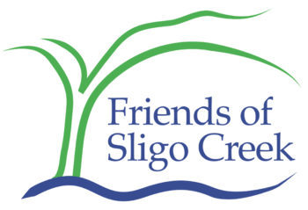

Friends of Sligo Creek
PO Box 11572
Takoma Park MD 20913

August 30, 2022

Mcp-chair@mncppc-mc.org
Silver Spring International Middle School
Mandatory Referral No. MR2022022

Chair Casey and Planning Board:

Silver Spring International Middle School, and the adjoining Sligo Creek Elementary School border Sligo Creek and its park. Already, in the process of creating the also adjoining Purple Line, many trees on the property were removed, and the State of Maryland has refused to plant replacement trees on the property after construction is complete. As well, the State has refused to address the full stormwater impacts of the increased impervious surface abutting the school. It is therefore up to the county to address these critical deficits.

So as part of the construction process, the plan should be to incorporate stormwater projects that both address the onsite construction as well as some of the roadway construction. And tree replanting should be integrated into the entire area that is not a playing field. This should include the new parking area at the corner of Dale and Wayne.

While we are sad to see the old auditorium, long disused, be taken down and replaced, at least the footprint of the school will not be increased.

Also energy efficient heating and air conditioning should be incorporated (all electric and heat pump), and solar collectors on the roof. Incorporate recycling and composting, and reduction in plastic use in the functioning of the school, including the cafeteria. Follow the new BEPS model Green Building mandates for a school that should be around for decades, and in all ways be an exemplar to the students and staff how to address Climate Change.

Friends of Sligo Creek, or FOSC, is a nonprofit community organization dedicated to protecting, improving, and appreciating the ecological health of Sligo Creek Park and its surrounding watershed.

Thank you for helping the school show the path to the future.

Kit Gage, Chair
Advocacy Committee, and Interim President
Friends of Sligo Creek
advocacy@fosc.org
www.friendsofsligocreek.org

