March 31, 2021

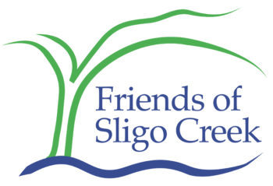

**Testimony to the Montgomery County Council on the Montgomery County Parks Budget**

**Kit Gage, Advocacy Director, Friends of Sligo Creek**

On behalf of Friends of Sligo Creek (FOSC), I am writing to express our strong support for Montgomery Parks to receive funding at or above last year’s level. Friends of Sligo Creek is a nonprofit community organization dedicated to protecting, improving, and appreciating the ecological health of Sligo Creek Park and its surrounding watershed.

The past year demonstrated clearly the value of our parks not just for preserving our natural environment, but for enhancing the physical and mental health of county residents, many of whom relied on county parks for exercise and socially distanced social gatherings during the past 12 months of pandemic restrictions.

We appreciate the many initiatives the Parks Department organized in 2020, such as the “open parkways” program, including the Halloween themed 5k and “Walk & Chalk” on Sligo Creek Parkway, that allowed more residents and especially children to experience and appreciate Sligo Creek. We believe that this kind of work should continue to be fully funded, as county residents deserve to benefit from such programming even after the COVID-19 pandemic recedes into history.

Despite the pandemic, the stress on streams such as Sligo Creek did not abate during 2020, and we urge the Council to continue supporting both stream restoration projects and, importantly, the ongoing maintenance of those projects, at current or even enhanced levels of funding.

Like many of our parks and even more so, Sligo Creek Park is a long and narrow stream valley park, and its viability is constantly threatened by encroaching stormwater and invasive plants that can compromise the health of native trees, shrubs, plants, animals, birds, and insects. This is why a sufficient budget for maintenance of completed projects, as well as for stormwater mitigation projects, is so critical, both for Sligo Creek Park and for other similar parks.

We urge you to maintain or increase the Montgomery Parks Department budget so that this and other vital work can be done effectively in a way that will continue to benefit Montgomery County residents for years to come.

*******

Kit Gage

Advocacy Director

Friends of Sligo Creek

P.O. Box 11572

Takoma Park, MD 20913

[www.friendsofsligocreek.org](http://www.friendsofsligocreek.org)

[advocacy@fosc.org](mailto:advocacy@fosc.org)